1 INTRODUCTION

1.1 Overview

Automatic number plate recognition (ANPR) is an image processing technology which uses number (license) plate to identify the vehicle. The objective is to design an efficient automatic authorized vehicle identification system by using the vehicle number plate. The system is implemented on the entrance for security control of a highly restricted area like military zones or area around top government offices e.g. Parliament, Supreme Court etc. The developed system first detects the vehicle and then captures the vehicle image. Vehicle number plate region is extracted using the image segmentation in an image. Optical character recognition technique is used for the character recognition. The resulting data is then used to compare with the records on a database so as to come up with the specific information like the vehiclepsilas owner, place of registration, address, etc. The system is implemented and simulated in Matlab, and it performance is tested on real image. It is observed from the experiment that the developed system successfully detects and recognize the vehicle number plate on real images.

1.2 Purpose

This project recognises the number from the number plate automatically and it gives output as characteristics(ASCII)

2 LITERATURE SURVEY

2.1 Existing problem

Traffic control and vehicle owner identification has become major problem in every country.

Sometimes it becomes difficult to identify vehicle owner who violates traffic rules and drives too fast. Therefore, it is not possible to

catch and punish those kinds of people because the traffic personal might not be able to retrieve vehicle number from the moving vehicle because of the

speed of the vehicle.

2.2 Proposed solution

Therefore, there is a need to develop Automatic Number Plate Recognition (ANPR) system as a one of the solutions to this problem. There are

numerous ANPR systems available today. These systems are based on different methodologies but still it is really challenging task as some of the factors

like high speed of vehicle, non-uniform vehicle number plate, language of vehicle number and different lighting conditions can affect a lot in the overall

recognition rate. Most of the systems work under these limitations.

3 THEORITICAL ANALYSIS

3.1 Block diagram

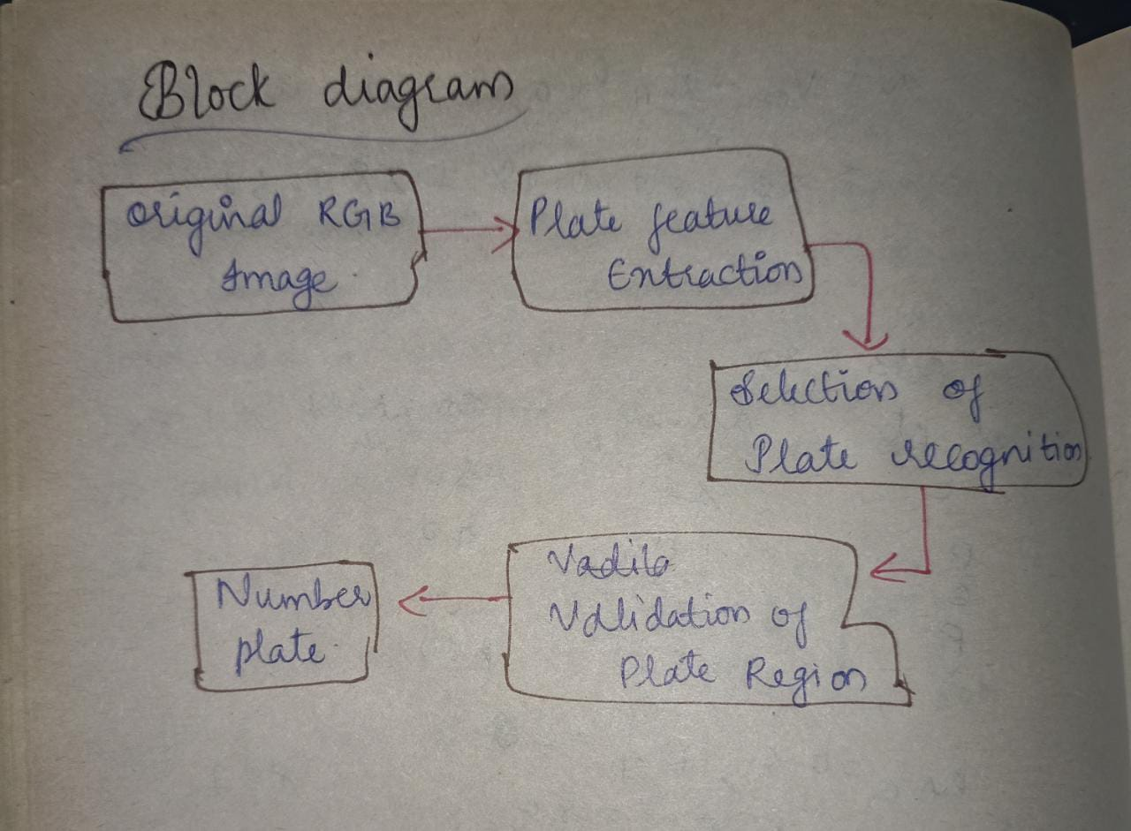

3.2 Hardware / Software designing

**AANPR HARDWARE**

|  |  |
| --- | --- |
| **HARDWARE** | **SOFTWARE** |
| ***CAMERA SYSTEM*** | ***APPLICATIONS*** |
| ***COMPUTER*** | ***SOFTWARE APPLICATION*** |
| ***FRAME GRABBER*** | ***DATA*** |

**NPR HARDWARE**

4 EXPERIMENTAL INVESTIGATIONS:

we have refered following  websites before doing our project

* https://www.ijert.org/research/automatic-number-plate-recognition-system-anpr-system-IJERTV3IS071132.pdf
* https://www.longdom.org/open-access/automatic-number-plate-recognition-0976-4860-2-408-422.pdf
* https://partheniumprojects.com/automatic-license-plate-recognition-using-image-processing/

5 FLOWCHART

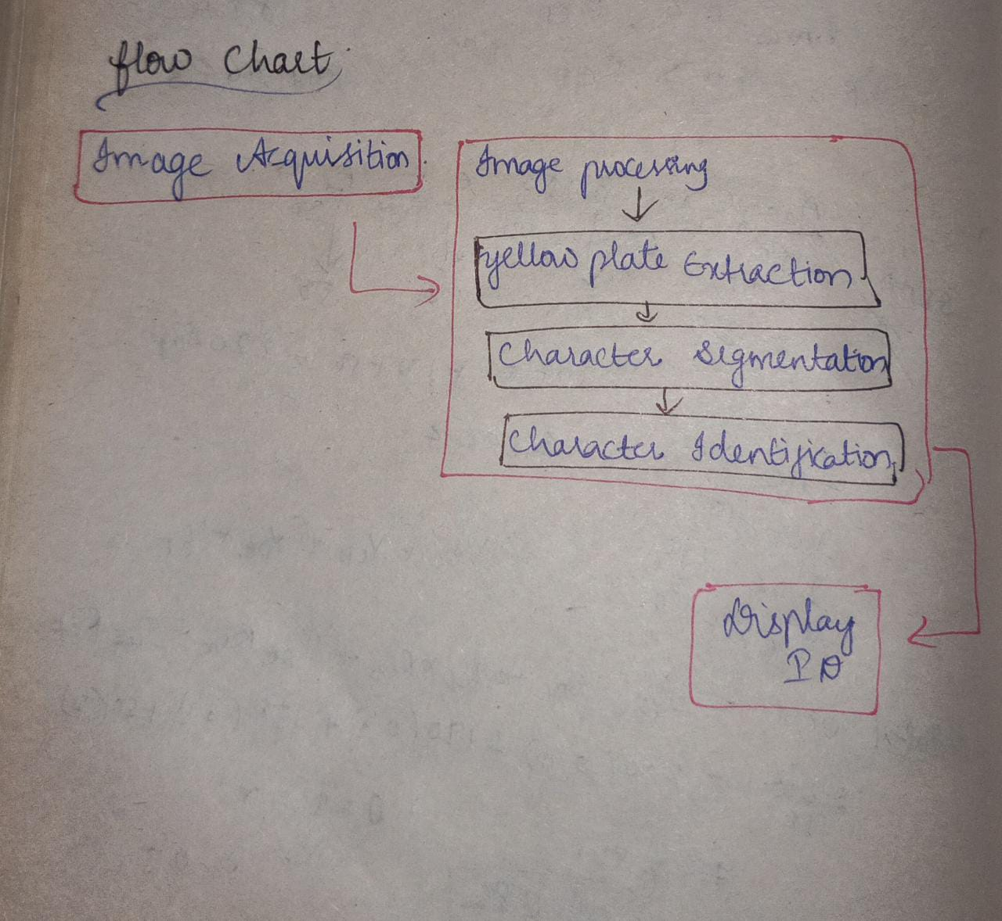

6 RESULT

here it will ask the url to enter of the number plate

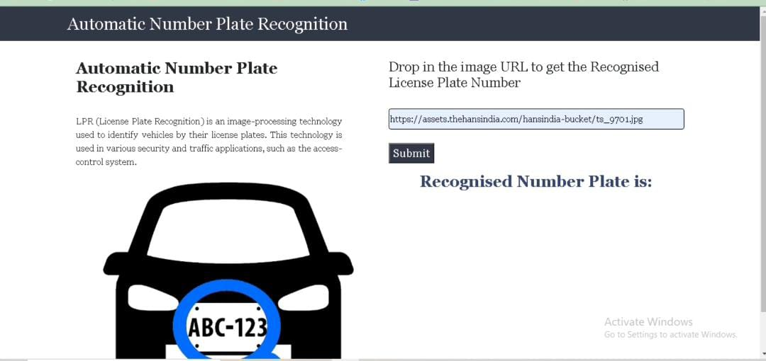

here this image url is taken so it should print this number from the number plate

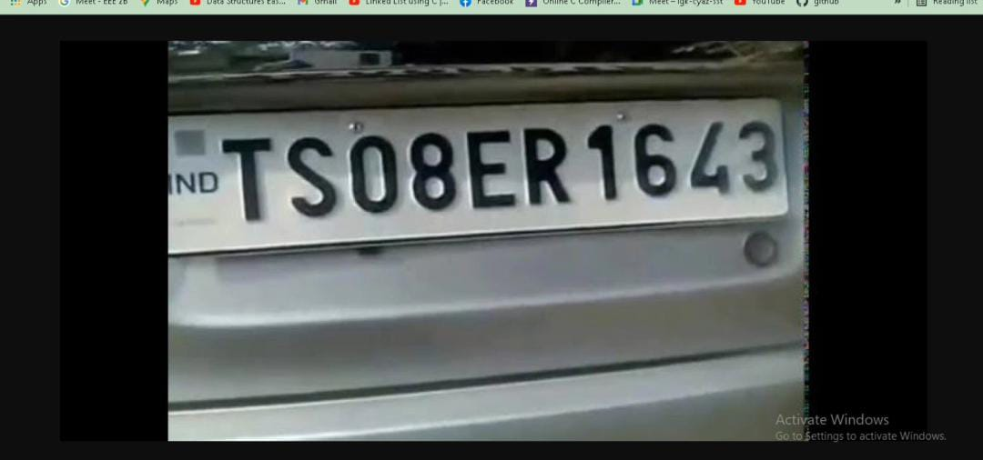

so finally it printed the output..

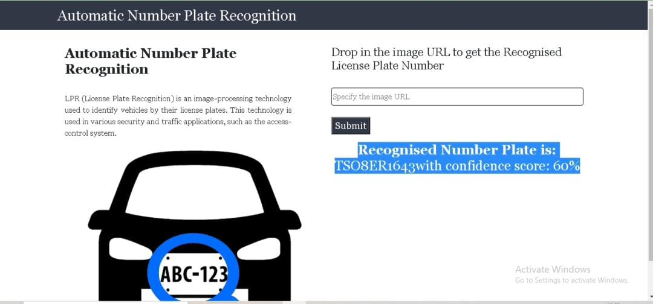

7 ADVANTAGES & DISADVANTAGES

**advantages**

1. adds security
2. automated service
3. real-time benefits
4. privacy concerns
5. extreme circumstances

**disadvantages**

A disadvantage of ANPR parking systems is that they rarely take into account human error and behaviour. ANPR systems do not usually consider giving a grace period when you enter a car park

The technology often uses low resolution images for which the images are actually not visible in ever case

8 APPLICATIONS

* Parking
* Access control
* Tolling
* Border control
* Stolen cars
* Traffic control

9 CONCLUSION

Hence we can conclude that ANPR solutions tend to gain a huge popularity today. Starting from enforcement to providing smoother day-to-day facilities, it has served all. Yet technology is evolving and you will get to see much advancements in the near future!

10 FUTURE SCOPE

Today advances technology took Automatic

Number Plate Recognition (ANPR) systems from hard to

set up, limited expensive, fixed based applications to

simple mobile ones in which “point to shoot” method can be

used. This is possible because of the creation of software

which ran on cheaper PC based and also non specialist

hardware in which their no need to give pre- defined direction,

angels, speed and size in which the plate would be passing the

camera field of view. Also Smaller cameras which can read

license plates at high speed, along with smaller, more durable

processors that can fit in police vehicles, allowed law

enforcement officers to patrol daily with the benefit of

license plate recognition in real time.

11 BIBILOGRAPHY

Refrences : https://www.slideshare.net/SairamGupthaTaduvai/automatic-number-plate-recognition-58697516

SOURCE CODE

this is html code

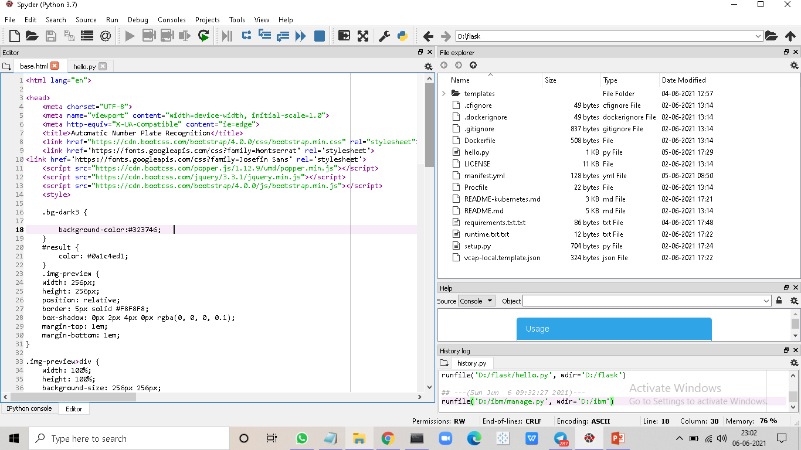

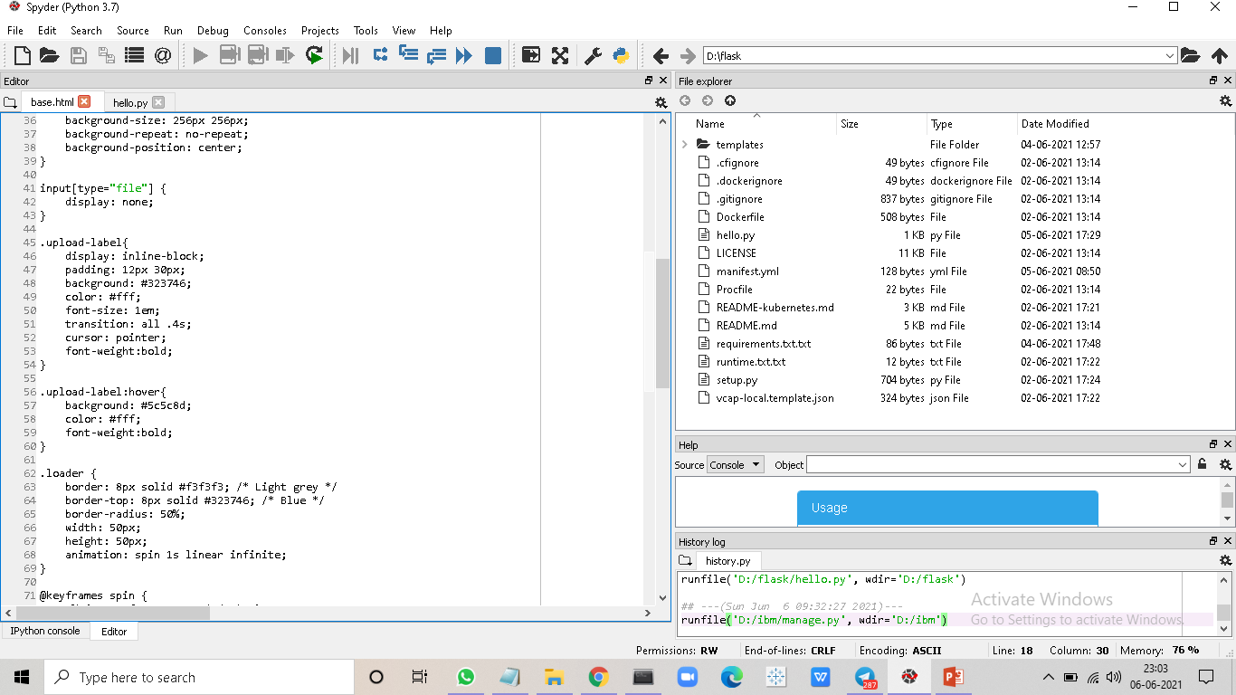

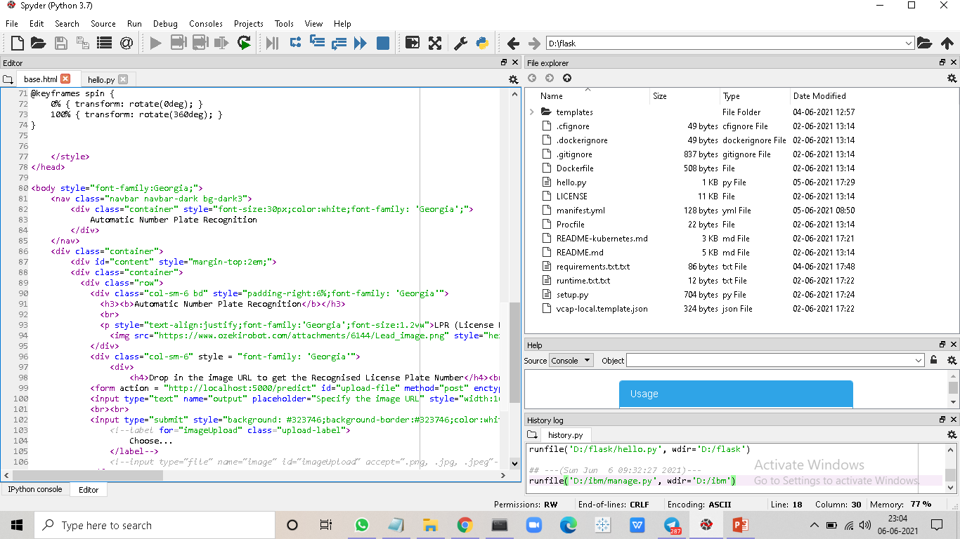

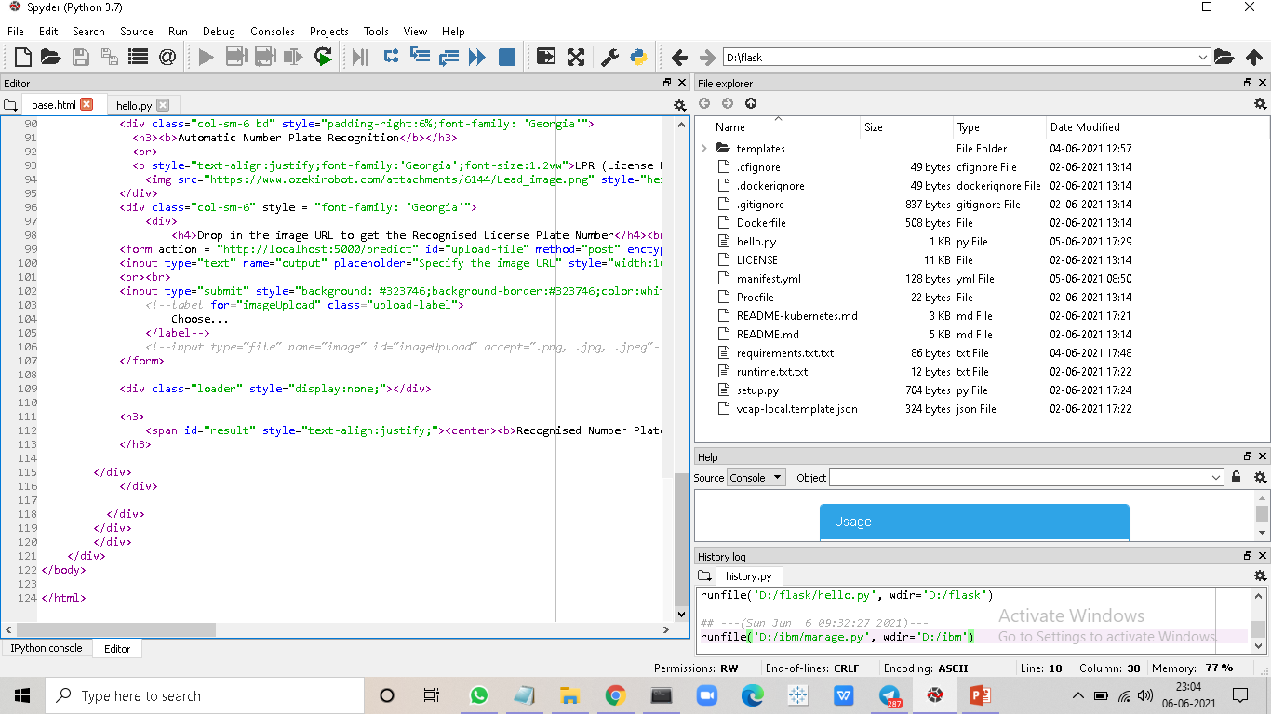

the below are the pictures of  python code

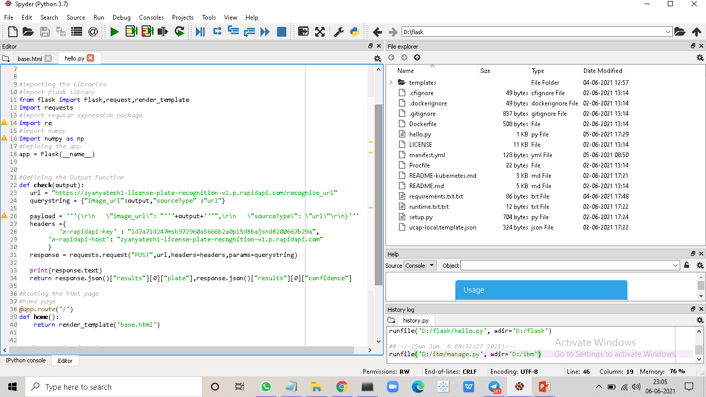

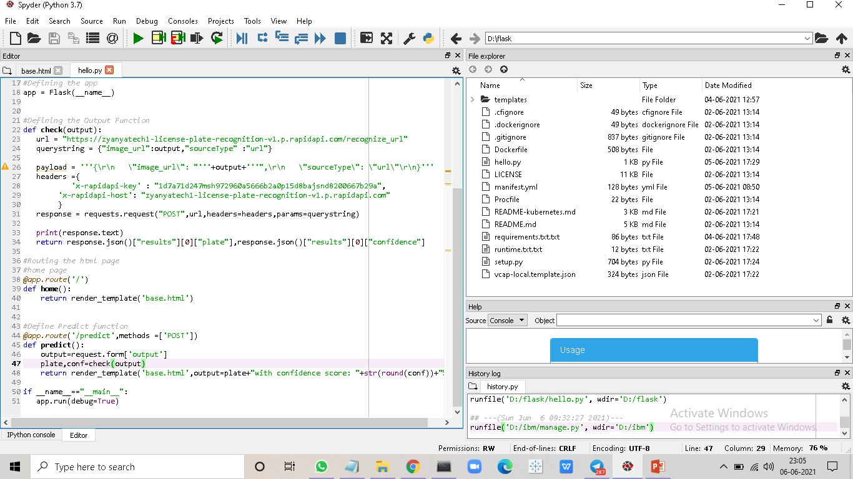

END OF PROJECT DOCUMENTATION

I was unable to submit the project files in git repo

so I created new repository and sended the files please look into this...

link : https://github.com/Lsony/GUIDED-PRJ-ANPR

assignments git hub link : https://github.com/smartinternz02/SI-GuidedProject-853-1619860242